Supplementary Figure 1

Supplementary Figure 2
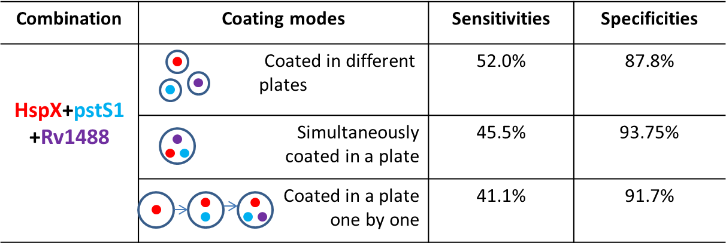
Supplementary Figure 3
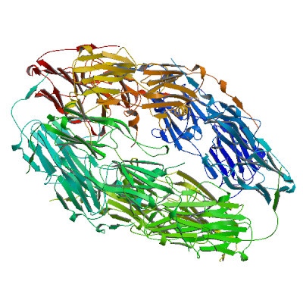

Supplementary Figure 4

Supplementary Figure 5

Supplementary Table 1 Clinical characteristics of the study population.
Characteristic | Active TB | Healthy control
Round one
Number | 72 | 24
Age, median (range) (yr) | 39.5 (23-52) | 41.3 (33-57)
Male/female | 47/25 | 15/9
sputum smear +/- | 32/40 | NA.#
Chest X-ray +/- | 23/49 | NA.
Round two
Number | 63 | 33
Age, median (range) (yr) | 35.8 (27-70) | 32.5 (18-71)
Male/female | 42/21 | 18/15
sputum smear +/- | 28/35 | NA.
Chest X-ray +/- | 19/34 | NA.
Round three
Number | 128 | 64
Age, median (range) (yr) | 33.8 (19-79) | 34.8 (23-62)
Male/female | 72/56 | 39/25
sputum smear +/- | 49/79 | NA.
Chest X-ray +/- | 36/92 | NA.
Round four
Period of enrollment (m, yr) | August 2016 - December 2017
# Abbreviation: N.A., not applicable

Supplementary Table 2 Using lysates from various bacteria for sera pre-adsorption to reduce non-specific reactions (for Rv1488)
Rv1488 | V. aquatilis | S. aureus | B. subtilis | S. epidermidis | P. vulgaris | E. aerogenes | γ-  streptococcus | S. citreus | E.  coli | Mixed | Back-  ground | NC
SFP | 0.479 | 0.387 | 0.423 | 0.393 | 0.171 | 0.127 | 0.422 | 0.414 | 0.091 | 0.078 | 0.466 | 0.015
WFP | 0.293 | 0.233 | 0.245 | 0.267 | 0.131 | 0.198 | 0.273 | 0.236 | 0.095 | 0.080 | 0.283 | 0.016
SP | 0.748 | 0.622 | 0.631 | 0.613 | 0.515 | 0.594 | 0.649 | 0.623 | 0.447 | 0.147 | 0.786 | 0.027
HC | 0.095 | 0.041 | 0.079 | 0.054 | 0.049 | 0.061 | 0.068 | 0.043 | 0.053 | 0.048 | 0.068 | 0.013
Abbreviation: Strong false positive, SFP; Weak false positive, WFP; strong positive, SP; Healthy control, HC; Negative control; Vibrio aquatilis, V. aquatilis; Staphylococcus aureus, S. aureus; Bacillus subtilis, B. subtilis; Proteus vulgaris, P. vulgaris; Staphylococcus albus, S. epidermidis; Enterobacter aerogenes, E. aerogenes; Staphylococcus citreus, S. citreus; Escherichia coli, E.coli.

Supplementary Table 3 Comparison of the effect of pre-adsorption by P. vulgaris, E. aerogenes and E. coli (for Rv1488)
Rv1488 | Background | E. coli | E. aerogenes | P. vulgaris | Mixed | Blank
SFP1 | 0.913 | 0.270 | 0.707 | 0.700 | 0.294 | 0.013
SFP2 | 1.075 | 0.271 | 0.296 | 0.272 | 0.196 | 0.009
SFP3 | 0.670 | 0.268 | 0.293 | 0.558 | 0.242 | 0.007
SFP4 | 0.305 | 0.209 | 0.177 | 0.222 | 0.166 | 0.008
SFP5 | 0.566 | 0.337 | 0.451 | 0.495 | 0.345 | 0.009
SFP6 | 0.360 | 0.174 | 0.202 | 0.191 | 0.153 | 0.016
SFP7 | 1.497 | 0.359 | 0.468 | 0.826 | 0.381 | 0.014
SFP8 | 0.407 | 0.193 | 0.248 | 0.222 | 0.219 | 0.011
SFP9 | 0.481 | 0.217 | 0.201 | 0.192 | 0.177 | 0.007
SFP10 | 1.203 | 0.180 | 0.222 | 0.184 | 0.147 | 0.007
SFP11 | 0.645 | 0.163 | 0.176 | 0.187 | 0.155 | 0.007
SFP12 | 0.434 | 0.196 | 0.201 | 0.214 | 0.210 | 0.009
SP1 | 0.357 | 0.235 | 0.199 | 0.192 | 0.197 | 0.007
SP2 | 0.705 | 0.171 | 0.363 | 0.196 | 0.147 | 0.009
HC1 | 0.159 | 0.147 | 0.144 | 0.135 | 0.089 | 0.009
HC2 | 0.092 | 0.054 | 0.077 | 0.094 | 0.047 | 0.007
Abbreviation: Strong false positive, SFP; Weak false positive, WFP; strong positive, SP; Healthy control, HC; Negative control

Supplementary Table 4 Predicted polypeptides of the fusion polyprotein
Rv. | Gene | Amio acid sequence | No.
Rv2031c | HspX | MATTLPVQRHPRSLFPEFSELFAAFPSFAGLRPTFDTRLMRLEDEMKEGRYEVRAELPGVDPDKDVDIMVRDGQLTIKAERTEQKDFDGRSEFAYGSFVRTVSLPVGADEDDIKATYDKGILTVSVAVSEGKPTEKHIQIRSTN | 144
Rv0934 | pstS1 | GSKPPSGSPETGAGAGTVATTPASSPVTLAETGS | 34
Rv1488 | - | TDPSIARAVATAEAIARKPVEGSLGTPPRLTQ | 32
Rv1980c | mpt64 | VRIKIFMLVTAVVLL | 15
Rv3601c | panD | ATMDDARARTYQPRIVFVDAYNKPIDMGHDPAFVPENAGELLDPRLGVG | 49
Rv0632c | echA3 | MSDPVSYTRKDSIAVISMDDGKVNALGPAMQQALNAAIDNADRDDVGALVITGNG | 55
Rv1623c | cydA | AQAAFTHTVSGALLTAGTFVAAVSAWWLVRSSTTHADSDTQA | 42
Rv1825 | - | VSENRPEPVAAETSAATTARHSQADAGAHDAVRRGRHELPADHPRSKVGPLRRTRLTEILRGGRSRLVFGTLAIL | 75
Rv3852 | hns | KGAKSAPPKPAEAPVSLQQRIET | 23

